

**Student Numbers: Emails: FIRST NAMES FAMILY / LAST NAMES**



C3166457@uon.edu.au



C3234811@uon.edu.au





C3238403@uon.edu.au





C3235146@uon.edu.au

**Course Code** **Course Title**



*(Example)*  *(Example)*



Campus of Study: Callaghan (eg Callaghan, Ourimbah, Port Macquarie)



Assessment Item Title: Assessment 1 Due Date/Time:



Tutorial Group (If applicable): Word Count (If applicable):

Lecturer/Tutor Name: Joe Ryan / Sharlene Von Drehnen

Extension Granted: Yes No Granted Until: 

Please attach a copy of your extension approval

**NB: STUDENTS MAY EXPECT THAT THIS ASSIGNMENT WILL BE RETURNED WITHIN 3 WEEKS OF THE DUE DATE OF SUBMISSION**







We declare that this assessment item is our own work unless otherwise acknowledged and is in accordance with the University’s [Student Academic Integrity Policy](http://www.newcastle.edu.au/about-uon/governance-and-leadership/policy-library/document?RecordNumber=D09/1899P) (<http://www.newcastle.edu.au/about-uon/governance-and-leadership/policy-library/document?RecordNumber=D09/1899P>) 

We certify that this assessment item has not been submitted previously for academic credit in this or any other course. We certify that we have not given a copy or have shown a copy of this assessment item to another student enrolled in the course, other than members of this group.

We acknowledge that the assessor of this assignment may, for the purpose of assessing this assignment:

* Reproduce this assessment item and provide a copy to another member of the Faculty; and/or
* Communicate a copy of this assessment item to a plagiarism checking service (which may then retain a copy of the item on its database for the purpose of future plagiarism checking).
* Submit the assessment item to other forms of plagiarism checking.

We certify that any electronic version of this assessment item that we have submitted or will submit is identical to this paper version.



Turnitin ID:

(if applicable)

Signature: __________ *BMcdonnell_* _______________________________________ Date: _______28/04/18_____

Signature: __________*AAnsell__ _*_________________________________________ Date: _______28/04/18_____

Signature: __________*RHurley*____________________________________________ Date: _______28/04/18_____

Signature: __________*Niamatullah*_________________________________________ Date: _______28/04/18_____

Signature: __________*MThomas*___________________________________________ Date: _______28/04/18

Seng2130

Assignment 1

University of Newcastle

Thursday 5-7PM, Group 5

Benjamin McDonnell, Alastair Ansell, Michael Thomas, Ross Hurley, Niamatullah

Tutor: Sharlene Von Drehnen

2018

Table of Contents

**Part 1a: Use Case Summaries…………………………………………………………………...3**

**Part 1b: Full Use Case Diagram………………………………………………………………...6**

# **Part 2: Fully developed use case descriptions………………………………………………….**8

**Part 3: Use Case Activity Diagrams…………………………………………………………...36**

**Part 4: Class Diagram………………………………………………………………………….64**

# Part 1a: Use Case Summaries

*Login*

**Login:**

Allows the user to log-in, has varying levels of control depending on if Employee or Manager.

*CHECK Price*

**Burial Price Listing:**

Manager attains the price for a chosen set of burial - this choice is determined through this use case by system prompt and user interaction.

**Cremation Price Listing:**

Manager attains the price for a chosen cremation scenario - this choice is determined through this use case by system prompt and user interaction.

**Services Price Listing:**

Manager attains the price for a chosen service - this choice is determined through this use case by system prompt and user interaction.

**Coffin Price Listing:**

Manager attains the price for a chosen coffin - this choice is determined through this use case by system prompt and user interaction.

**Urn Price Listing:**

Manager attains the price for a chosen urn - this choice is determined through this use case by system prompt and user interaction.

**Flowers Price Listing:**

Manager attains the price for a chosen flower type- this choice is determined through this use case by system prompt and user interaction.

**Simplicity Package Price Listing:**

Manager attains the price for the simplicity package.

**Perpetual Care Price Listing:**

Manager attains the price for a chosen perpetual care package - this choice is determined through this use case by system prompt and user interaction.

*Set Price*

**Set Burial Price:**

User sets prices for different burial types.

**Set Cremation Price:**

Enables Manager to initially set / update price for different cremation scenarios.

**Set Services Price:**

Enables Manager to initially set / update a service scenario (pastor AND graveside, no pastor AND graveside, no pastor AND chapel, pastor AND chapel).

**Set Coffin Price:**

Enables Manager to initially set/ update prices for certain coffins- the system saves the prices entered for choice of coffin type.

**Set Urn Price:**

Enables Manager to initially set/ update prices for certain urns - the system saves the prices entered for choice of urn type.

**Set Flowers Price:**

Enables the Manager to set unit prices (i.e. price of one flower) for the available flower types. The system saves this entered price.

**Set Simplicity Package Price:** Enables manager to initially set / update the price of the simplicity package.

**Set Perpetual Care Price:**

Enables the Manager to initially set / update the price of perpetual care package for a certain burial plot. The system then saves this price.

*Make Order*

**Order Coffin:**

The system will order a coffin and notify relevant staff members/contractors after a customer select the size and material of a coffin.

**Order Urn:**

The system orders an urn after a customer selects type of urn required.

**Simplicity Funeral:**

If customer choses simplicity funeral option, the system will order all the default funeral options and notify relevant members responsible.

**Perpetual Care:**

System orders the perpetual care package to the user’s specifications.

*Cancel Order*

**Cancel Order:**

Cancels a previous order when it is no longer needed.

*Check Resource Availability*

**Get Grave Availability:**

Enables a user (manager, employee) needs to get the chapel availability / unavailability.

**Get Crematorium Availability:**

Enables a user (manager, employee) to check the availability / unavailability of the crematorium.

**Get Chapel Availability:**

Enables a user (manager, employee) to check the availability / unavailability of the chapel.

**Get Service Availability:**

Enables a user (manager, employee) to check the availability / unavailability of pastor(s).

*Set Resource Availability*

**Set Grave Availability:**

Enables a user (manager / employee) to set the unavailability of certain grave type for a certain time and for what reason this unavailability is occurring.

**Set Crematorium Availability:**

Enables a user (manager / employee) to set the unavailability of the crematorium for a certain time and for what reason this unavailability is occurring.

**Set Chapel Availability:**

Enables a user (manager / employee) to set the unavailability of the chapel for a certain time and for what reason this unavailability is occurring.

**Set Service Availability:**

Enables a user (religious organisation) to set the availability of a pastor for a date / time.

*Check Roster*

**Check Roster:**

Enables an employee to check their roster for their current work period - they may also log out while visiting this section of the system.

*Set Roster*

**Set Roster:**

Manager sets roster for one week in advance.

*Check Daily Tasks*

**Check Daily Tasks:**

This list is automatically generated by the system to be accessed by employees to get updates on what needs to be done.

# Part 1b: Full Use Case Diagram

The System will have a login for all employees to be able to access their individual account where they will be able to clock on and off work and be able to check all work associated for their specialization inside the day’s work use case.

Managers will have further permissions assigned for them including; assigning work, which will put data into the system under days’ work, manage staff where they can add, remove and change employee’s specialization, and set price where they can change the prices of the services provided by Pearly Gates Cemetery and Crematorium.

All employees will be able to check availability of any assigned resources through the check availability use case and will be able to set the availability using the Set resource availability use case.

All employees will also be able to check the price of all individual services provided by the company including; cremation, burial, services, and all care package options through the check price use case.

All employees will be able to place orders through the system in a specific order. Once the order use case has been chosen either cremation or burial will be chosen, and all options related to those use cases will be selectable continuing onwards. Burial type and cremation type will then further limit the continuing options depending the choice made inside the use cases. Coffin type and Urn type will then finalize the specific selections and set the rest of the restrictions for extras. Care packages will only be selectable by orders meeting the correct conditions. Flowers will be selectable by all orders. Services will be selectable by orders that have met the condition and the option to have the service occur first will be given for orders choosing cremation.

On a request where flowers are not on-site a florist will be contacted to send flowers requested by the employee.

On a request for service, a religious organization will be contacted and given the date and time required of them.

Example: Employee selects Order, then selects Burial, will be given the options under burial type being; Lawn cemetery, Monument, Mausoleum or green. The employee chooses green and Coffin type will be restricted to Biodegradable bag or basket. The order will then be available to have the care package, flowers and services afterwards but not before as it meets those conditions.

# 

# Part 2: Fully developed use case descriptions

|  |  |  |
| --- | --- | --- |
| Use case Name: | LOGIN | |
| Brief description | Logs the employee into the system | |
| Actors | Employee | |
| Related Use Cases | Check Availability, Check Roster, Check Price, Order, Set Resource Availability | |
| Entry Condition | When an employee attempts to login to the system | |
| Exit condition | When the employees login is successful | |
| Flow of Events | **Actors** | **System** |
| 1. Employee Clicks login | 1.1 system prompts for Username and Password |
| 2 Employee provides username and password. | 2.1 system logs the user on. |
| Exception Conditions | 1. User cancels login attempts then System exits the login use case  2.2 if Employee provides invalid username and password then system takes uses back event 2. | |

**Summary of LOGIN:** Allows the user to log-in, has varying levels of control depending on if Employee or Manager. Will alert user if Username or Password is incorrect.

|  |  |  |
| --- | --- | --- |
| Use case Name | BURIAL PRICE LISTING | |
| Brief description | Manager attains the price for a chosen set of burial - this choice is determined through this use case by system prompt and user interaction | |
| Actors | Manager | |
| Related Use Cases | CHECK PRICE (it generalizes this use case) | |
| Entry Condition | When a customer calls looking to learn prices for burial – the manager will visit the burial price section of the system | |
| Exit condition | The user hits exit (available from any stage of events as the system requires no information from the user that would be entered and saved) | |
| Flow of Events | Actors | System |
| 1. Manager selects BURIAL PRICES | 1.1 System prompts user to make a choice: ADULT or CHILD |
| 2. Manager chooses option from ADULT or CHILD from System prompt | 2.1 System prompts user to make a choice: LAWN CEMETERY, MONUMENT or GREEN. |
| 3. Manager chooses option from LAWN CEMETERY, MONUMENT, or GREEN from system prompt | 3.1 System outputs relevant price based on the previous user selections (see the price tree figure) |
| Exception Conditions |  | |

|  |
| --- |
| **Alternate Flow** |
| 2.1.a if Manager chooses Monument they are prompted to make a further choice – either-or **a single design from a specific list of monument designs** or **user specified design**.  2.1.a if Manager chooses GREEN hey are prompted to choose between **on-site** or **off-site.**  3.1 .aif Manager has previously chosen MONUMENT and **user specified design** then the outputted price will have a disclaimer that this is a starting price as the user specified design will have a starting price and may vary depending on how elaborate the user specified design will be. |

**Summary of BURIAL PRICE LISTING**: Manager attains a burial price from the system after entering whether a child or adult is buried, which style of burial is taking place (lawn cemetery, monument etc..).

**Note:** Mausoleum is not offered as a choice in BURIAL price listing as Mausoleum is not currently offered.

|  |  |  |
| --- | --- | --- |
| Use case Name | CREMATION PRICE LISTING | |
| Brief description | Manager attains the price for a chosen cremation scenario - this choice is determined through this use case by system prompt and user interaction | |
| Actors | Manager | |
| Related Use Cases | CHECK PRICE (it generalizes this use case) | |
| Entry Condition | When a customer calls looking to learn prices for cremations – the manager WILL VISIT the cremation price section of the system | |
| Exit condition | The user hits exit (available from any stage of events as the system requires no information from the user that would be entered and saved) | |
| Flow of Events | Actors | System |
| 1. Manager selects CREMATION PRICES | 1.1 System prompts user to make a choice: ADULT or CHILD |
| 2. Manager chooses option from ADULT or CHILD from System prompt | 2.1 System prompts user to make a choice: PRIVATE CREMATION or PUBLIC CREMATION |
|  | 3. Manager chooses option from PRIVATE CREMATION or PUBLIC CREMATION | 3.1 System prompts user to make a choice:  OFF-SITE ASH SCATTERING or ON-SITE ASH SCATTER |
|  | 4. Manager chooses option from OFF-SITE ASH SCATTERING or ON-SITE ASH SCATTER | 4.1 System outputs relevant price based on the previous user selections |
| Exception  Conditions |  | |

**Summary of CREMATION PRICE LISTING:** Manager attains a cremation price from the system after entering whether a child or adult is being cremated, whether or not this cremation will be held publicly or not and whether the ash scattering will be on-site or off-site.

**Note:** The choice whether the cremation will be held publicly or not does make a difference to the price because if the cremation is held publicly then a space to accommodate a sizeable crowd will need to be rented out.

The choice whether the ashes will be scattered on-site / off-site also matters as on-site requires space and a plaque.

|  |  |  |
| --- | --- | --- |
| Use case Name | SERVICES PRICE LISTING | |
| Brief description | Manager attains the price for a chosen service - this choice is determined through this use case by system prompt and user interaction | |
| Actors | Manager | |
| Related Use Cases | CHECK PRICE (it generalizes this use case) | |
| Entry Condition | When a customer calls looking to learn service prices – the manager WILL VISIT the service price section of the system | |
| Exit condition | The user hits exit (available from any stage of events as the system requires no information from the user that would be entered and saved) | |
| Flow of Events | Actors | System |
| 1. Manager selects SERVICE PRICES | 1.1 System prompts user to make a choice: PASTOR or NO PASTOR |
| 2. Manager chooses option from PASTOR or NO PASTOR from System prompt | 2.1 System prompts user to make choice: GRAVESIDE or CHAPEL |
|  | 3. Manager chooses option GRAVESIDE or CHAPEL | 3.1 System outputs relevant price based on the previous user selects (See the price tree figure) |
| Exception  Conditions |  | |

**Summary of SERVICES PRICE LISTING:** Manager attains a price for the services required from the system after entering whether a pastor is required or not and whether the service will be taking place in the chapel or graveside.

|  |  |  |
| --- | --- | --- |
| Use case Name | COFFIN PRICE LISTING | |
| Brief description | Manager attains the price for a chosen coffin - this choice is determined through this use case by system prompt and user interaction | |
| Actors | Manager | |
| Related Use Cases | CHECK PRICE (it generalizes this use case) | |
| Entry Condition | When a customer calls looking to learn coffin prices – the manager WILL VISIT the coffin price section of the system | |
| Exit condition | The user hits exit (available from any stage of events as the system requires no information from the user that would be entered and saved) | |
| Flow of Events | Actors | System |
| 1. Manager selects COFFIN prices | 1.1 System prompts user with list of prices |
| Exception  Conditions |  | |

**Summary of COFFIN PRICE LISTING:** Manager attains a price for a specific coffin from the system.

|  |  |  |
| --- | --- | --- |
| Use case Name | URN PRICE LISTING | |
| Brief description | Manager attains the price for a chosen coffin / urn - this choice is determined through this use case by system prompt and user interaction | |
| Actors | Manager | |
| Related Use Cases | CHECK PRICE (it generalizes this use case) | |
| Entry Condition | The manager WILL VISIT the coffin / urn price section of the system | |
| Exit condition | The user hits exit (available from any stage of events as the system requires no information from the user that would be entered and saved) | |
| Flow of Events | Actors |  |
| 1. Manager selects URN prices | 1.1 System prompts user with list of prices |
| Exception Conditions |  | |

**Summary of URN PRICE LISTING:** Manager attains a price for a specific urn type from the system.

|  |  |  |
| --- | --- | --- |
| Use case Name | FLOWERS PRICE PRICE LISTING | |
| Brief description | Manager attains the price for a chosen flower type- this choice is determined through this use case by system prompt and user interaction | |
| Actors | Manager | |
| Related Use Cases | CHECK PRICE (it generalizes this use case) | |
| Entry Condition | When a customer calls looking to learn prices of flowers – the manager WILL VISIT the service price section of the system | |
| Exit condition | The user hits exit (available from any stage of events as the system requires no information from the user that would be entered and saved) | |
| Flow of Events | Actors | System |
| 1. Manager selects FLOWER prices | 1.1 System outputs a list of flowers types available. |
|  | 2. Manager enters chooses a flower type | 2.1 System outputs the price |
| Exception Conditions |  | |

**Summary of FLOWERS PRICE LISTING**: Manager attains a price for a specific type of flower they offer, they can then multiply that specific amount by the amount the customer is looking to quote.

|  |  |  |
| --- | --- | --- |
| Use case Name | SIMPLICITY PACKAGE PRICE LISTING | |
| Brief description | Manager attains the price for the simplicity package | |
| Actors | Manager | |
| Related Use Cases | CHECK PRICE (it generalizes this use case) | |
| Entry Condition | When a customer calls looking to learn the price of the simplicity package – the manager WILL VISIT the SIMPLICITY PACKAGE PRICE LISTING section of the system | |
| Exit condition | The user hits exit (available from any stage of events as the system requires no information from the user that would be entered and saved) | |
| Flow of Events | Actors | System |
| 1. Manager selects SIMPLICITY PACKAGE PRICE | 1.1 System outputs the price of the simplicity package price |
| Exception Conditions |  | |

**Summary of SIMPLICITY PACKAGE PRICE LISTING**:  
The simplicity package is a predefined set of orders (coffin, flower arrangements, service etc.) which can be ordered as a convenience for customers looking not to configure / tweak a funeral service from the ground up.

Manager attains a price for the simplicity package offered by the company from the system.

|  |  |  |
| --- | --- | --- |
| Use case Name | PERPETUAL CARE PRICE LISTING | |
| Brief description | Manager attains the price for a chosen perpetual care package - this choice is determined through this use case by system prompt and user interaction | |
| Actors | Manager | |
| Related Use Cases | CHECK PRICE (it generalizes this use case) | |
| Entry Condition | When a customer calls looking to learn the price of the perpetual care – the manager WILL VISIT the PERPETUAL CARE PRICE LISTING section of the system | |
| Exit condition | The user hits exit (available from any stage of events as the system requires no information from the user that would be entered and saved) | |
| Flow of Events | Actors | System |
| 1. Manager selects PERPETUAL CARE price section | 1.1 System prompts user for a choice: LAWN CEMETERY, MONUMENT, GREEN. |
|  | 2. Manager selects from the choices given | 2.1 System outputs relevant price to user. |
| Exception Conditions |  | |

**Summary of PERPETUAL CARE PRICE LISTING**: Manager attains the price for a certain a price for a specific perpetual care package

**Note about set price use cases:**

In all the set price uses cases the Manager will need to liaise with employees / contractors to determine the prices set but the manager will ultimately set the price - price is determined by multiple factors (the market, cost of resources etc.) but the manager ultimately decides these.

|  |  |  |
| --- | --- | --- |
| Use case Name | SET BURIAL PRICES | |
| Brief description | User sets prices for different burial types | |
| Actors | Manager | |
| Related Use Cases | SET PRICE (it generalizes this use case) | |
| Entry Condition | When the Manager needs to initially set / update burial prices the Manager will enter the set burial price section of the system. | |
| Exit condition | The user enters a price (after choosing which specific burial price is being altered) and the system saves this price. | |
| Flow of Events | Actors | System |
| 1. Manager selects SET BURIAL PRICES | 1.1 System prompts user to make a choice: ADULT or CHILD |
| 2. Manager chooses option from ADULT or CHILD from System prompt | 2.1 System prompts user to make a choice: LAWN CEMETERY, MONUMENT or GREEN |
| 3. Manager chooses option from LAWN CEMETERY, MONUMENT, or GREEN from system prompt | 3.1 System prompts user to enter a price. |
|  | 4. Manager enters a price | 3.2 System saves this price. |
| Exception Conditions |  | |

|  |
| --- |
| **Alternative Flow** |
| 2.1 if Manager chooses LAWN CEMETERY they are prompted to make a further choice – either-or a **plaque** or a **simple cross** is included in the pricing.  2.1 if Manager chooses Monument they are prompted to make a further choice – either-or **a single design from a specific list of monument designs** or **user specified design**.  4. If the manager enters an invalid price (negative, non-number etc.) then the system will return to 3.1 |

**Summary of SET BURIAL PRICES:** Enables Manager to initially set / update the prices for different burial types offered.

Note: It is assumed that if the Manager has previously chosen MONUMENT and **user specified design** then the price entered by the manager will be the starting price.

|  |  |  |
| --- | --- | --- |
| Use case Name | SET CREMATION PRICE | |
| Brief description | Enables Manager to initially set / update price for different cremation scenarios. | |
| Actors | Manager | |
| Related Use Cases | SET PRICE (it generalizes this use case) | |
| Entry Condition | When the Manager needs to initially set / update cremation prices the Manager will enter the set cremation price section of the system. | |
| Exit condition | The user enters a price and the system saves this price. | |
| Flow of Events | Actors | System |
| 1. Manager selects SET CREMATION PRICES | 1.1 System prompts user to make a choice: PRIVATE or PUBLIC |
| 2. Manager chooses option from PRIVATE or PUBLIC from System prompt | 2.1 System prompts user to make a choice:  OFF-SITE ASH SCATTERING or ON-SITE ASH SCATTER |
|  | 3. Manager chooses option from OFF-SITE ASH SCATTERING or ON-SITE ASH SCATTER | 3.1 System prompts user to enter a price |
|  | 4. Manager enters a price | 4.1 System saves the price |
| Exception Conditions | 4. If the manager enters an invalid price (negative, non-number etc.) then the system will return to 3.1 | |

**Summary of SET CREMATION PRICE:** Enables Manager to initially set / update price for different cremation scenarios.

|  |  |  |
| --- | --- | --- |
| Use case Name | **SET SERVICES PRICE** | |
| Brief description | Enables Manager to initially set / update a service scenario (pastor AND graveside, no pastor AND graveside, no pastor AND chapel, pastor AND chapel) | |
| Actors | Manager | |
| Related Use Cases | SET PRICE (it generalizes this use case) | |
| Entry Condition | When the Manager needs to initially set / update service prices - the manager will visit the set service prices section of the system. | |
| Exit condition | The user enters a price and the system saves this price. | |
| Flow of Events | Actors | System |
| 1. Manager selects SERVICE PRICES | 1.1 System prompts user to make a choice: PASTOR or NO PASTOR |
| 2. Manager chooses option from PASTOR or NO PASTOR from System prompt | 2.1 System prompts user to make choice: GRAVESIDE or CHAPEL |
|  | 3. Manager chooses option GRAVESIDE or CHAPEL | 3.1 System prompts user to enter a price |
|  | 4. Manager enters price | 4.1 System saves this price |
| Exception Conditions | 4. If the manager enters an invalid price (negative, non-number etc.) then the system will return to 3.1 | |

**Summary of SET SERVICES PRICE**: Enables Manager to initially set / update a service scenario (pastor AND graveside, no pastor AND graveside, no pastor AND chapel, pastor AND chapel). This section of the system is available from the set prices menu which is only accessible to the manager.

|  |  |  |
| --- | --- | --- |
| Use case Name | SET COFFIN PRICE | |
| Brief description | Enables Manager to initially set/ update prices for certain coffins - the system saves the prices entered for choice of coffin type. | |
| Actors | Manager | |
| Related Use Cases | SET PRICE (it generalizes this use case) | |
| Entry Condition | When the Manager needs to initially set/update coffin prices - the manager will visit the set coffin prices section of the system. | |
| Exit condition | The user enters a price and the system saves this price. | |
| Flow of Events | Actors | System |
| 1. Manager selects set COFFIN PRICE | 1.1 System prompts user to choose a coffin type: |
| 2. Manager chooses coffin type | 2.1 System prompts user to enter a price |
|  | 3. Manager enters a price | 3.1 System saves this price. |
| Exception Conditions | 3. If the manager enters an invalid price (negative, non-number etc.) then the system will return to 2.1 | |

**Summary of COFFIN PRICE LISTING:** Enables Manager to initially set/ update prices for certain coffins - the system saves the prices entered for choice of coffin type. This section of the system is accessible via the set prices menu of the system.

|  |  |  |
| --- | --- | --- |
| Use case Name | SET URN PRICE | |
| Brief description | Enables Manager to initially set/ update prices for certain urns - the system saves the prices entered for choice of urn type. | |
| Actors | Manager | |
| Related Use Cases | SET PRICE (it generalizes this use case) | |
| Entry Condition | When the Manager needs to initially set/update urn prices - the manager will visit the set urn prices section of the system. | |
| Exit condition | The user enters a price and the system saves this price. | |
| Flow of Events | Actors | System |
| 1. Manager selects set URN PRICE | 1.1 System prompts user to choose an urn type: |
| 2. Manager chooses urn type | 2.1 System prompts user to enter a price |
|  | 3. Manager enters a price | 3.1 System saves this price. |
| Exception Conditions | 3. If the manager enters an invalid price (negative, non-number etc.) then the system will return to 2.1 | |

**Summary of COFFIN PRICE LISTING:** Enables Manager to initially set/ update prices for certain urns - the system saves the prices entered for choice of urn type. This section of the system is accessible via the set prices menu of the system.

|  |  |  |
| --- | --- | --- |
| Use case Name | SET FLOWERS PRICE | |
| Brief description | Enables the Manager to set unit prices (i.e. price of one flower) for the available flower types. The system saves this entered price. | |
| Actors | Manager | |
| Related Use Cases | SET PRICE (it generalizes this use case) | |
| Entry Condition | When the Manager needs to initially set / update flower prices - the manager will visit the set flower prices section of the system. | |
| Exit condition | The user enters a price and the system saves this price. | |
| Flow of Events | Actors | System |
| 1. Manager selects FLOWER prices | 1.1 System outputs a list of flower types available |
|  | 2. Manager selects a flower type | 2.1 System prompts user for a price to enter |
|  | 3. Manager enters price | 3.1 System saves this price |
| Exception Conditions | 3. If the manager enters an invalid price (negative, non-number etc.) then the system will return to 2.1 | |

**Summary of SET FLOWERS PRICE**: Enables the Manager to set unit prices (i.e. price of one flower) for the available flower types. The system saves this entered price.

|  |  |  |
| --- | --- | --- |
| Use case Name | SET SIMPLICITY PACKAGE PRICE | |
| Brief description | Enables manager to initially set / update the price of the simplicity package. | |
| Actors | Manager | |
| Related Use Cases | SET PRICE (it generalizes this use case) | |
| Entry Condition | When the Manager needs to initially set / update simplicity package price - the manager will visit the set flower prices section of the system. | |
| Exit condition | The user enters a price and the system saves this price. | |
| Flow of Events | Actors | System |
| 1. Manager selects SIMPLICITY PACKAGE PRICE | 1.1 System prompts the user to set a price |
|  | 2. Manager enters a price | 2.1 System saves this price |
| Exception Conditions | 2. If the manager enters an invalid price (negative, non-number etc.) then the system will return to 1.1 | |

**Summary of SET SIMPLICITY PACKAGE PRICE**: Enables manager to initially set / update the price of the simplicity package.

|  |  |  |
| --- | --- | --- |
| Use case Name | SET PERPETUAL CARE PRICE | |
| Brief description | Enables the Manager to initially set / update the price of perpetual care package for a certain burial plot. The system then saves this price | |
| Actors | Manager | |
| Related Use Cases | SET PRICE (it generalizes this use case) | |
| Entry Condition | When the Manager needs to initially set / update perpetual care price - the manager will visit the set flower prices section of the system. | |
| Exit condition | The user enters a price and the system saves this price. | |
| Flow of Events | Actors | System |
| 1. Manager selects PERPETUAL CARE price section | 1.1 System prompts user for a choice: LAWN CEMETERY, MONUMENT, GREEN. |
|  | 2. Manager selects from the choices given | 2.1 System prompts user to enter a price |
|  | 3. Manager enters a price | 3.1 System saves this price |
| Exception Conditions | 3. If the manager enters an invalid price (negative, non-number etc.) then the system will return to 2.1 | |

**Summary of SET PERPETUAL CARE PRICE**: Enables the Manager to initially set / update the price of perpetual care package for a certain burial plot. The system then saves this price

|  |  |  |
| --- | --- | --- |
| Use case Name: | Burial Order | |
| Brief description | The system will input the variables needed for the Burial | |
| Actors | Manager | |
| Related Use Cases | Includes: Order Coffin Generalisations: | |
| Entry Condition | When a customer chooses to have their loved ones buried | |
| Exit condition | The system finishes processing the order | |
| Flow of Events | **Actors** | **System** |
| 1. The Manager selects BURIAL ORDER | 1.1 System Prompts for Date and Time |
| 2. Manager inputs Date and Time | 2.1 System Accepts or Rejects Date and Time if available  2.2 System Prompts ADULT or CHILD |
| 3. Manager inputs ADULT or CHILD | 3.1 System Prompts LAWN CEMETERY, MONUMENT or GREEN |
|  | 4. Manager Selects One of The Options: LAWN CEMETERY, MONUMENT or GREEN | 4.1 System Prompts options related to each different Burial option |
|  | 5. Manager Selects Options Relevant to Previous Selected Burial Option | 5.1 System Displays Pricing |
|  | 6. Manager Confirms Pricing with Customer | 6.1 If Confirmed, Order is processed by System |
| Exception Conditions |  | |

|  |
| --- |
| Alternative Flow |
| 4.1.a Once the manager selects one option from LAWN CEMETERY, MONUMENT or GREEN, the following options will show up:   1. IF Option = LAWN CEMETERY, the manager will be able to select from: PLAQUE or CROSS 2. IF Option = GREEN, the manger will be able to select from: OFF-SITE or ON-SITE 3. IF Option = MONUMENT, the manager will be able to select from: SINGLE DESIGN or USER SPECIFIED DESIGN   4.1.a IF manager selects MONUMENT and USER SPECIFIED DESIGN, Show Warning Disclaimer |

**Use Case Description:** Enables a user (manager/employee) to put through a burial order for a customer. This section of the system is accessible via the general order menu (has links to all order sections).

|  |  |  |
| --- | --- | --- |
| Use case Name: | Order Coffin | |
| Brief description | the system will order a coffin and notify relevant staff members/contractors after a customer select the size and material of a coffin. | |
| Actors | Manager | |
| Related Use Cases | Includes: Select Size, Select Materials  Generalizations: For Adults, For Kids, Walnut, Oak, Basket, biodegradable bag | |
| Entry Condition | When a customer chose to order a coffin for funeral | |
| Exit condition | The system finishes processing order | |
| Flow of Events | **Actors** | **System** |
| 1. Manager selects order coffin | 1.1 system prompts for Select Coffin Size |
| 2. manager selects required size of coffin | 2.1 system prompts for Select coffin materials |
| 3. manager selects desired coffin material | 3.1 system show the price for selected size and material of coffin |
| 4. manager confirm the price with customer and press order button | 4.1 the system check availability of materials and the earliest date and time a customized coffin can be delivered. |
| 5. manager confirm the material type and the date and time with customer and finalise the order. | 5.1 system process the order and send notification to coffin relevant employees / contractors once payment has been made by customer. |
| Exception Conditions |  | |

|  |  |
| --- | --- |
| **Alternative Flow** |  |
| 1. if customer decides to cancel before confirming the price, date and time.  a. manager cancels the coffin order  b. system goes back to the start of order section  2. if the system check resources and the required resources are not available.   1. the system will prompt for changing the selection of materials 2. if the change is not accepted, the system will not proceed with this order and the user may cancel if the materials used, date and time the product can get ready is not accepted by the customer. | |

**Use Case (Order Coffin) description**: this use case let the user select a range of different coffins available for offer, includes two sizes - adults or kids and made of different materials such as walnut, oak, basket or biodegradable bags. the system can also produce prices based on the material and size of coffin. the system can also check the availability of required resources. it displays the details to the user and by confirming the price, size and materials, the system can place the order once the payment is accepted and send instructions to relevant employees / contractors.

|  |  |  |
| --- | --- | --- |
| Use case Name: | Order Urn | |
| Brief description | the system orders an urn after a customer selects type of urn required | |
| Actors | Manager | |
| Related Use Cases | Generalizations: Disposable box, metal, ceramic | |
| Entry Condition | When a customer chose to order an urn for funeral | |
| Exit condition | The system finishes processing order | |
| Flow of Events | Actors | System |
| 1. Manager selects order urn | 1.1 system prompts for Select urn type |
| 2. manager selects required urn type | 2.1 system show the price for selected urn type |
| 3. manager confirm the price with customer and press order button | 3.1 system check availability of requested type urn. |
| 4. manager confirm availability of requested type of urn. | 4.1 system process the order and send notification to relevant employees / contractors once payment has been made by customer. |
| Exception Conditions |  | |

|  |
| --- |
| **Alternative Flow** |
| 1. if customer decides to cancel before confirming the price,  a. manager cancels the urn order  b. system goes back to the start of order section  2. if the requested type of urn is not available, the system will prompt to alter the type. if customer accept the change, the system will proceed to step 4.1. else the order cannot be placed, and the manager may need to cancel the order. |

**Use Case (Order Urn) description**: this use case let the user select a range of different urns available for offer, with the options of choosing disposable box (if the ashes are to be scattered), metal or ceramic (if the customer want to display it in niche wall or private home). the system can also produce prices based on the material selected. the system can also check the availability of selected type of urns. it displays the details to the user and by confirming the price and material used, the system can place the order once the payment is accepted and send instructions to relevant employees / contractors.

|  |  |  |
| --- | --- | --- |
| Use case Name: | Simplicity funeral | |
| Brief description | If customer choses simplicity funeral option, the system will order all the default funeral options and notify relevant members responsible. | |
| Actors | Manager | |
| Related Use Cases | Include: Package Type  Generalizations: Adults Package, Kids Package. | |
| Entry Condition | When a customer chose simplicity funeral option | |
| Exit condition | The system finishes processing order | |
| Flow of Events | Actors | System |
| 1. Manager selects Simplicity Funeral | 1.1 system prompts for Date and Time |
| 2. Manager selects Date and Time | 2.1 system show the price for selected simplicity funeral package |
| 3. Manager selects required package | 3.1 System show the price of selected simplicity funeral package |
| 4. Manager confirms the price and customer and press order button. | 4.1 System check for availability of required resources and materials used |
|  | 5. User confirms the availability of resources | 5.1 System processes the order and sends notification to relevant employees/contractors once payment has been made by customer |
| Exception Conditions | 1. if customer decides to cancel before confirming the price,  a. manager cancels the simplicity funeral package  b. system goes back to the start of order section | |

**Use Case (Simplicity Funeral) description**: simplicity funeral package includes all the basic services and materials needed for a funeral and these packages are not customizable. this use case let the user select from one of the two packages available for offer (adults or kids package). the system can also produce prices based on the type of package selected and check the availability of required materials, resources and machineries. it displays the details to the user and by confirming the price the system can reserve machinery and resources and place the order once the payment is accepted and send instructions to relevant employees / contractors.

|  |  |  |
| --- | --- | --- |
| Use Case Name: | ORDER PERPETUAL CARE PACKAGE | |
| Brief Description | System orders the perpetual care package to the user’s specifications | |
| Actors | Manager, Employee | |
| Related Use Cases | Care package (this generalises that) | |
| Entry Condition | User chooses to order the perpetual care package | |
| Exit Condition | System finishes the perpetual care order, or user closes/exits/cancels order | |
| Flow of Events | Actors |  |
|  | 1. User selects ORDER PERPETUAL CARE | 1.1 System prompts user to make a choice: SEPARATE OR FUNERAL ADDON |
|  | 2. User selects either SEPARATE OR FUNERAL ADDON | 2.1 System displays price  2.2 System prompts user to confirm or cancel the order placement |
|  | 3. User confirms | 3. System processes this order and saves the date / time and resources needed for the time of this order. |
| Exception Conditions | 2.2 If User decides to cancel the order then the user will be brought back to the general order menu. | |

**Use Case Description:** Perpetual care is the option to have ongoing care to your gravesite/monument. This includes several features and can be chosen as an option when putting in your burial order, for a price.

|  |  |  |
| --- | --- | --- |
| Use case Name: | Cancel Order | |
| Brief description | Cancels a previous order when it is no longer needed. | |
| Actors | Manager | |
| Related Use Cases | Includes: | |
| Entry Condition | When a customer calls to cancel their order. When an order is no longer valid. | |
| Exit condition | The system finishes processing cancellation. | |
| Flow of Events | **Actors** | **System** |
| 1. Manager selects Cancel Order | 1.1 system Displays list of orders |
| 2. manager selects Order | 2.1 system Displays order info  2.2 system prompts for cancellation |
| 3. manager Confirms | 3.1 system cancels the order  3.2 system releases the relevant resources |
| Exception Conditions | 1. Manager rejects the cancellation  a. System returns to main menu | |

**Use Case (Order Coffin) description**: this use case let the user cancel orders that are no longer needed. It begins after the option “Cancel Order” is selected from the main menu, the system will then list all orders for the manager to select one, the manager selects an order to view more information and is prompted with “cancel order” and “go back” buttons. Cancel Order will cancel the order and finish the use case, Go Back will return user to the Menu.

|  |  |  |
| --- | --- | --- |
| Use case Name | GET GRAVE AVAILABILITY | |
| Brief description | Enables a user (manager / employee) needs to get the chapel availability / unavailability. | |
| Actors | Manager, Employee | |
| Related Use Cases | GET AVAILABILITY (THIS GENERALISES THAT) | |
| Entry Condition | When the manager or an employee needs to check the availability of resources / time they will visit the GET GRAVE AVAILABILITY section of the system | |
| Exit condition | The user hits exit (available from any stage of events as the system requires no information from the user that would be entered and saved) | |
| Flow of Events | Actors | System |
| 1. User selects GET GRAVE AVAILABILITY | 1.1 System prompts user to make a choice: SCHEDULE OF GRAVESIDE SERVICES, SCHEDULE OF GRAVESIDE DIGGINGS, SCHEDULE OF GRAVESIDE RESOURCES |
| 2. User chooses option from SCHEDULE OF GRAVESIDE SERVICES, SCHEDULE OF GRAVESIDE DIGGINGS, SCHEDULE OF GRAVESIDE RESOURCES from System prompt | 2.1 System prompts user with a relevant scheduling. |
| Exception Conditions |  | |

**Summary of GET GRAVE AVAILABILITY**: A manager or employee will be able to login to the system, then via the “Availability” menu, the user can then select “Grave Availability” to get the current availabilities for services, diggings or to see if/when resources will be accessible**.**

|  |  |  |
| --- | --- | --- |
| Use case Name | GET CREMATORIUM AVAILABILITY | |
| Brief description | Enables a user (manager, employee) to check the availability / unavailability of the crematorium. | |
| Actors | Manager, Employee | |
| Related Use Cases | GET AVAILABILITY (THIS GENERALISES THAT) | |
| Entry Condition | When the manager or an employee needs to check the availability of resources / time they will visit the GET CREMATORIUM AVAILABILITY section of the system | |
| Exit condition | The user hits exit (available from any stage of events as the system requires no information from the user that would be entered and saved) | |
| Flow of Events | Actors | System |
| 1. User selects GET CREMATORIUM AVAILABILITY | 1.1 System prompts user to make a choice: SCHEDULE OF CREMATIONS, SCHEDULE OF CLEANINGS / MAINTENANCE |
| 2. User chooses option from SCHEDULE OF CREMATIONS, SCHEDULE OF CLEANINGS / MAINTENANCE from System prompt | 2.1 System prompts user with a relevant scheduling. |

**Summary of GET CREMATORIUM AVAILABILITY**: Enables a user (employee/ manager) to see the scheduled use of the crematorium - namely when cremations are happening and when planned maintenance is to occur.

|  |  |  |
| --- | --- | --- |
| Use case Name | GET CHAPEL AVAILABILITY | |
| Brief description | Enables a user (manager, employee) to check the availability / unavailability of the chapel. | |
| Actors | Manager, Employee | |
| Related Use Cases | GET AVAILABILITY (THIS GENERALISES THAT) | |
| Entry Condition | When the manager or an employee needs to check the availability of chapel time / resources they will visit the GET CHAPEL AVAILABILITY section of the system | |
| Exit condition | The user hits exit (available from any stage of events as the system requires no information from the user that would be entered and saved) | |
| Flow of Events | Actors | System |
| 1. User selects GET CHAPEL AVAILABILITY | 1.1 System prompts user to make a choice: SCHEDULE OF CHAPEL SERVICES, SCHEDULE OF CLEANINGS / MAINTENANCE |
| 2. User chooses option from SCHEDULE OF CHAPEL SERVICES, SCHEDULE OF CLEANINGS / MAINTENANCE from System prompt | 2.1 System prompts user with a relevant scheduling. |

**Summary of GET CHAPEL AVAILABILITY**: Enables a user (employee/ manager) to see the scheduled use of the chapel, as the chapel is a resource that cannot be double-booked knowing the scheduled use of the chapel is important to staff. Available from the get general check availability menu.

|  |  |  |
| --- | --- | --- |
| Use case Name | GET SERVICE AVAILABILITY | |
| Brief description | Enables a user (manager, employee) to check the availability / unavailability of pastor(s). | |
| Actors | Manager, Employee | |
| Related Use Cases | GET AVAILABILITY (THIS GENERALISES THAT) | |
| Entry Condition | When the manager or an employee needs to check the availability of chapel time / resources they will visit the GET SERVICE AVAILABILITY section of the system | |
| Exit condition | The user hits exit (available from any stage of events as the system requires no information from the user that would be entered and saved) | |
| Flow of Events | Actors | System |
| 1. User selects GET SERVICE AVAILABILITY | 1.1 System outputs user with schedule of pastor availability |

**Summary of GET SERVICE AVAILABILITY**: Enables a user (employee / manager) to see the availability of a pastor - this is relevant to chapel and graveside ceremonies.

|  |  |  |
| --- | --- | --- |
| Use case Name | SET GRAVE AVAILABILITY | |
| Brief description | Enables a user (manager / employee) to set the unavailability of certain grave type for a certain time and for what reason this unavailability is occurring. | |
| Actors | Manager, Employee | |
| Related Use Cases | SET AVAILABILITY (THIS GENERALISE THAT) | |
| Entry Condition | When the manager or an employee needs to set the availability of resources / time they will visit the SET GRAVE AVAILABILITY section of the system | |
| Exit condition | The user enters the availability for the relevant resource (date / time) and the system then saves this information | |
| Flow of Events | Actors | System |
| 1. User selects SET GRAVE AVAILABILITY | 1.1 System prompts user to make a choice: SCHEDULE OF GRAVESIDE SERVICES, SCHEDULE OF GRAVESIDE DIGGINGS, SCHEDULE OF GRAVESIDE RESOURCES |
| 2. User chooses option from SCHEDULE OF GRAVESIDE SERVICES, SCHEDULE OF GRAVESIDE DIGGINGS, SCHEDULE OF GRAVESIDE RESOURCES from System prompt | 2.1 System prompts user to enter a date / time |
|  | 3. User enters a time | 3.1 System saves this date / time |
| Exception Conditions | 2.1 if user has chosen SCHEDULE OF GRAVESIDE SERVICES then the system will also prompt user to enter a place (which part of the plot will the graveside be occupying)  2.1 if user has chosen SCHEDULE OF GRAVESIDE DIGGINGS then the system will also prompt user to enter a place (where is the grave being dug)  2.1 if user has chosen SCHEDULE OF GRAVESIDE RESOURCES then the system will prompt user to make a choice of what resource (machinery, marquis, shovels etc.) is being utilized at that time.  3.1 if user has chosen SCHEDULE OF GRAVESIDE SERVICES then the system also saves the place the user entered  3.1 if user has chosen SCHEDULE OF GRAVESIDE DIGGINGS then the system also saves the place the user entered  3.1 if user has chosen SCHEDULE OF GRAVESIDE RESOURCES then the system also saves the choice of resource the user made | |

**Summary of SET GRAVE AVAILABILITY**: Enables a user (employee / manager) to set the availability of a graveside - the time / date of unavailability and the reason why (graveside services, graveside diggings, graveside resources not availability during this time e.g. the sling is being repaired during this time).

|  |  |  |
| --- | --- | --- |
| Use case Name | SET CREMATORIUM AVAILABILITY | |
| Brief description | Enables a user (manager / employee) to set the unavailability of the crematorium for a certain time and for what reason this unavailability is occurring. | |
| Actors | Manager, Employee | |
| Related Use Cases | SET AVAILABILITY (THIS GENERALISES THAT) | |
| Entry Condition | When the manager or an employee needs to set the availability of resources / time they will visit the SET CREMATORIUM AVAILABILITY section of the system | |
| Exit condition | The user enters the availability for the relevant resource (date / time) and the system then saves this information | |
| Flow of Events | Actors | System |
| 1.User selects SET CREMATORIUM AVAILABILITY | 1.1 System prompts user to make a choice: SCHEDULE OF CREMATIONS, SCHEDULE OF CLEANINGS / MAINTENANCE |
| 2. User chooses option from SCHEDULE OF CREMATIONS, SCHEDULE OF CLEANINGS / MAINTENANCE from System prompt | 2.1 System prompts user to enter a date / time |
|  | 3. User enters a date / time | 3.1 System saves this date / time |
| Exception Conditions |  | |

**Summary of SET CREMATORIUM AVAILABILITY**: Enables a user (employee / manager) to set the availability of the crematorium - the time / date of unavailability and the reason why (cremation taking place, maintenance taking place).

|  |  |  |
| --- | --- | --- |
| Use case Name | SET CHAPEL AVAILABILITY | |
| Brief description | Enables a user (manager / employee) to set the unavailability of the chapel for a certain time and for what reason this unavailability is occurring. | |
| Actors | Manager, Employee | |
| Related Use Cases | SET AVAILABILITY (THIS GENERALISES THAT) | |
| Entry Condition | When the manager or an employee needs to set the availability of chapel time / resources they will visit the SET CHAPEL AVAILABILITY section of the system | |
| Exit condition | The user enters the availability for the relevant resource (date / time) and the system then saves this information | |
| Flow of Events | Actors | System |
| 1. User selects SET CHAPEL AVAILABILITY | 1.1 System prompts user to make a choice: SCHEDULE OF CHAPEL SERVICES, SCHEDULE OF CLEANINGS / MAINTENANCE |
| 2. User chooses option from SCHEDULE OF CHAPEL SERVICES, SCHEDULE OF CLEANINGS / MAINTENANCE from System prompt | 2.1 System prompts user to enter a date / time |
|  | 3. User enters a date / time | 3.1 System saves this date / time |
| Exception Conditions |  | |

**Summary of SET CHAPEL AVAILABILITY**: Enables a user (employee / manager) to set the availability of the chapel - the time / date of unavailability and the reason why (chapel service taking place, maintenance taking place).

|  |  |  |
| --- | --- | --- |
| Use case Name | SET SERVICE AVAILABILITY | |
| Brief description | Enables a user (religious organisation) to set the availability of a pastor for a date / time. | |
| Actors | Religious Organisation | |
| Related Use Cases | SET AVAILABILITY (THIS GENERALISES THAT) | |
| Entry Condition | When the manager or an employee needs to set the availability of chapel time / resources they will visit the SET SERVICE AVAILABILITY section of the system | |
| Exit condition | The user enters the availability for the relevant resource (date / time) and the system then saves this information | |
| Flow of Events | Actors | System |
| 1. User selects SET SERVICE AVAILABILITY | 1.1 System prompts user to enter a date / time |
|  | 2. User enters a date / time | 2.1 System saves this date / time |
| Exception Conditions |  | |

**Summary of SET SERVICE AVAILABILITY**: Enables a user (religious organisation) to set the availability of a pastor - the time / date of availability / unavailability.

|  |  |  |
| --- | --- | --- |
| Use case Name | CHECK ROSTER | |
| Brief description | Enables an employee to check their roster for their current work period - they may also log out while visiting this section of the system | |
| Actors | Employee | |
| Related Use Cases | Login (This includes Login) | |
| Entry Condition | When an employee needs to check their roster, they will visit | |
| Exit condition | The user hits exit (available from any stage of events as the system requires no information from the user that would be entered and saved) OR the user hits log out which takes them back to the login section of the system | |
| Flow of Events | Actors | System |
| 1. User selects GET ROSTER | 1.1 System outputs the days worked for the employee logged in for the current roster period.  1.1 System also prompts the user with an option to log out |
| Exception Conditions | 1.1 if the user selects log out the system will take the user to the login section of the system. | |

**Summary of CHECK ROSTER:** Enables an employee to check their roster for the current work period. It is assumed that the employee would have logged in with their credentials. This use case is activated after an employee selects check roster from the main menu.

|  |  |  |
| --- | --- | --- |
| **Use Case Name:** | **Set Roster** | |
| **Brief description** | Manager sets roster for one week in advance | |
| **Actors** | Manager | |
| **Related Use Cases** |  | |
| **Entry Condition** | Manager starts to update roster for the week | |
| **Exit condition** | When the roster is updated | |
| **Flow of Events** | **Actors** | **System** |
| 1. Manager select set roster. | 1.1 System produce list of current employees |
| 2. Manager selects required number of employees for the week and assign shifts. | 2.1 system updates the roster and saves the data |
| **Exception Conditions** | 1. If an employee listed in weekly roster want to take a day off    1. Manager should assign someone to replace him/her    2. And update the roster to make sure work is only assigned to available employees | |

**Use Case (Set Roster) description**: Manager assign shifts to specific employees one week in advance so that employee can check their roster and be ready for their shift. If an employee listed in weekly roster want to take a day off, must let the office know so that manager can find replacement for him/her and assign work only to those employees who are available

|  |  |  |
| --- | --- | --- |
| **Use Case Name:** | **Assign Work** | |
| **Brief description** | Once the system processes the order and confirm that payment has been made, the system will assign work to relevant employees / contractors. | |
| **Actors** | Manager | |
| **Related Use Cases** | Include: Check Roster, daily tasks | |
| **Entry Condition** | When the system finishes processing order, this use case will update the Daily Task List and assign work to relevant employees / contractors to produce the product or provide the requested service. | |
| **Exit condition** | When work has been assigned to employees / contractors and Daily Task list has been updated. | |
| **Flow of Events** | **Actors** | **System** |
| 1. Manager selects assign work. | 1.1 system recall check roster and produces a list of available employees / contractors. |
| 2. Manager select a specific department or person that need to perform the work. | 2.1 system assign work and updates Daily Task list. |
| **Exception Conditions** |  | |

**Use Case (Assign Work) description**: every time the system processes a new order, the system prompts to assign work to specific department or employees.

|  |  |  |
| --- | --- | --- |
| **Use Case Name:** | **Daily Tasks** | |
| **Brief description** | This list is automatically generated by the system to be accessed by employees to get updates on what needs to be done. | |
| **Actors** | Employees, manager | |
| **Related Use Cases** |  | |
| **Entry Condition** | When employees want to check daily task list. | |
| **Exit condition** | The employee close viewing daily tasks | |
| **Flow of Events** | **Actors** | **System** |
| 1. employee select daily tasks | 1.1 System displays up to date version of daily tasks. |
| 2. Employee closes viewing the list. | 2.1 system go back to main page. |

**Use Case (Daily Tasks) description**: for the convenience of employees and managers, the system or the manager will create and update daily task list that can be accessed by employees to be able to know what work has been assigned to them. This solves the problem of employees calling the office every time they want to know what work has been assigned to them.

# Part 3: Use Case Activity Diagrams

## Login

## 

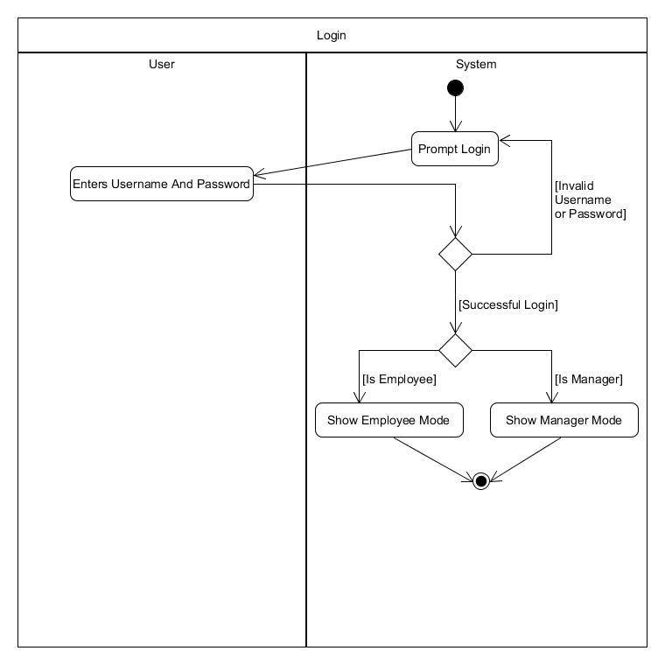

## Get Prices

## 

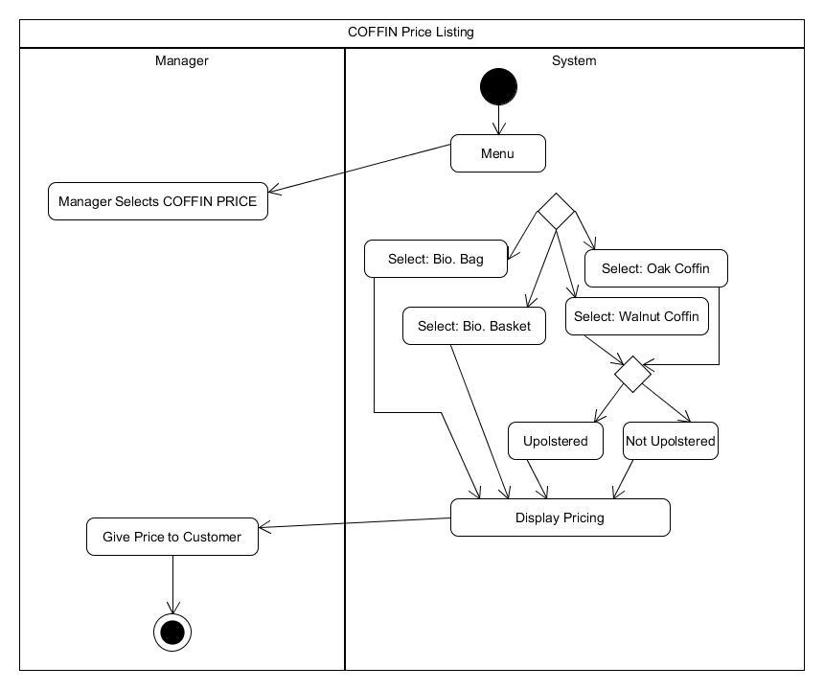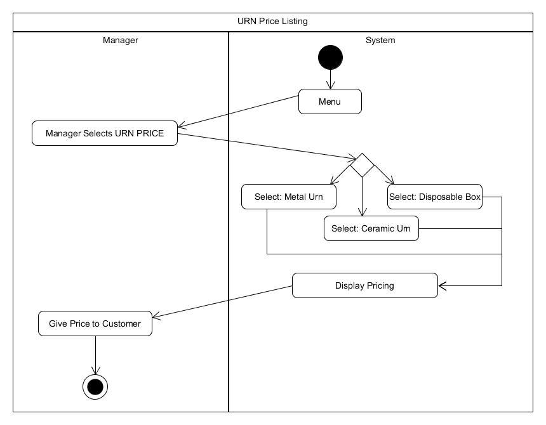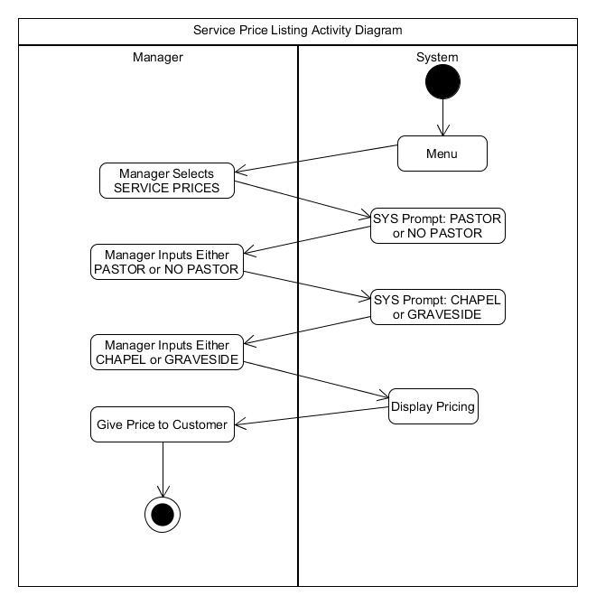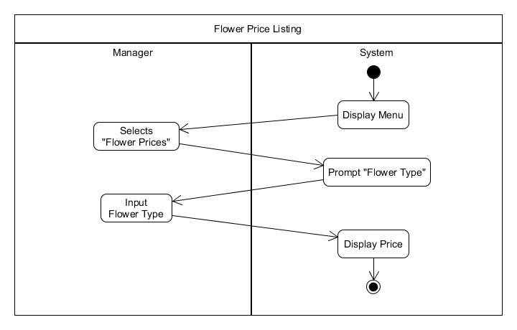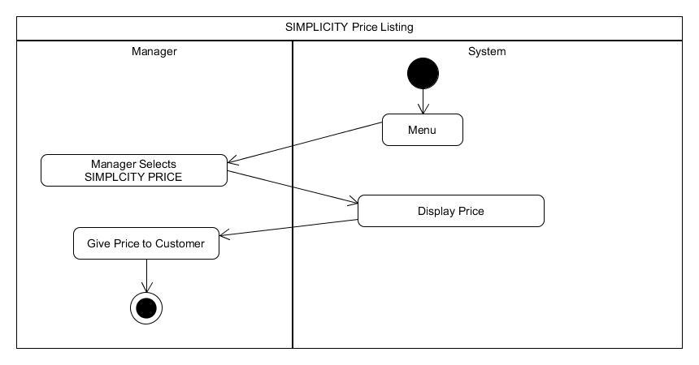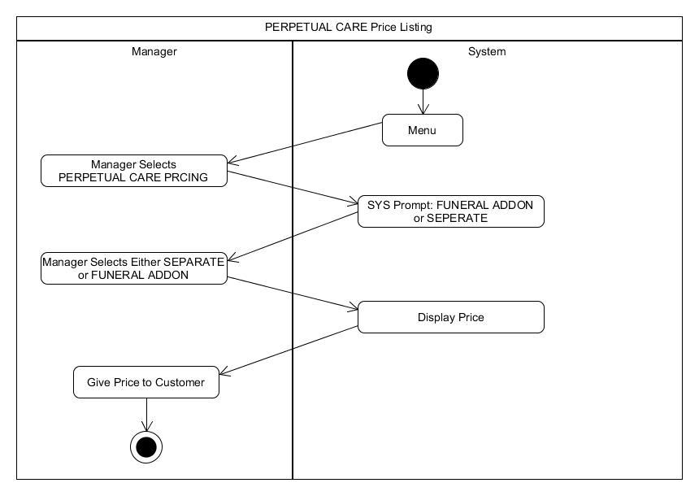

## Set Prices

## 

## 

## Make Order

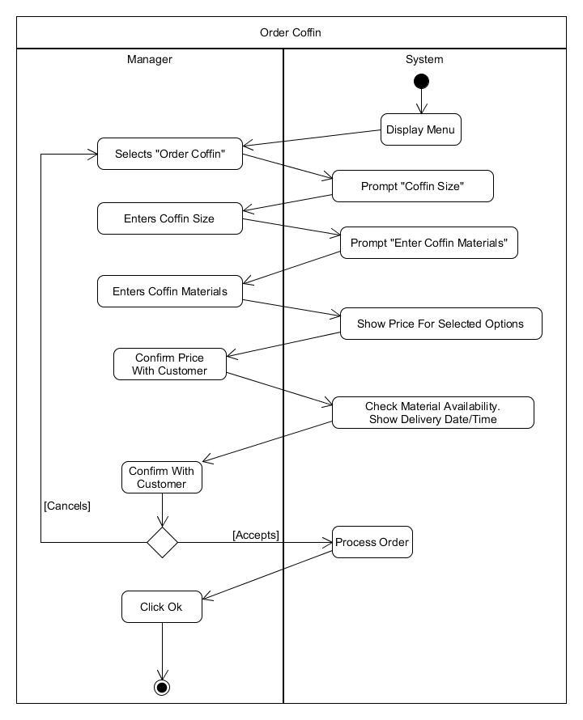

## 

## Cancel Order

## Check Resource Availability

## Set Resource Availability

## Check Roster

## 

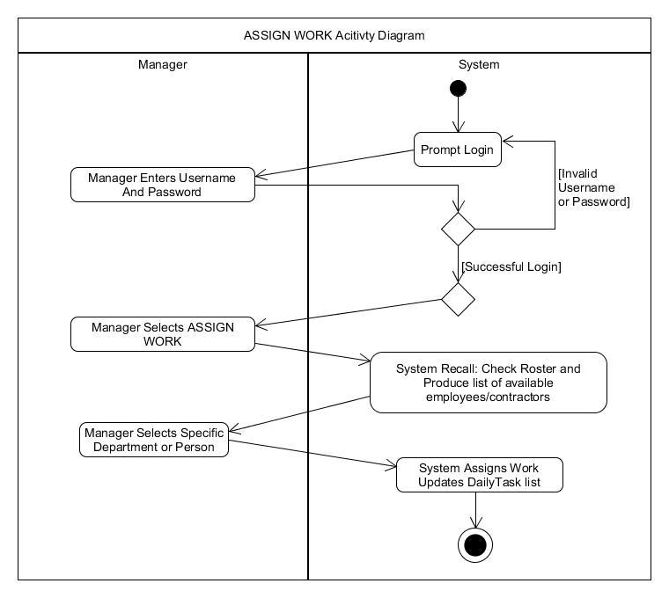

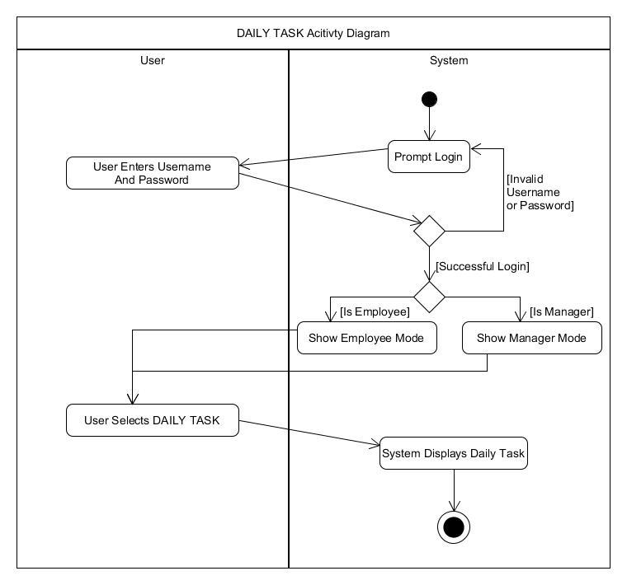

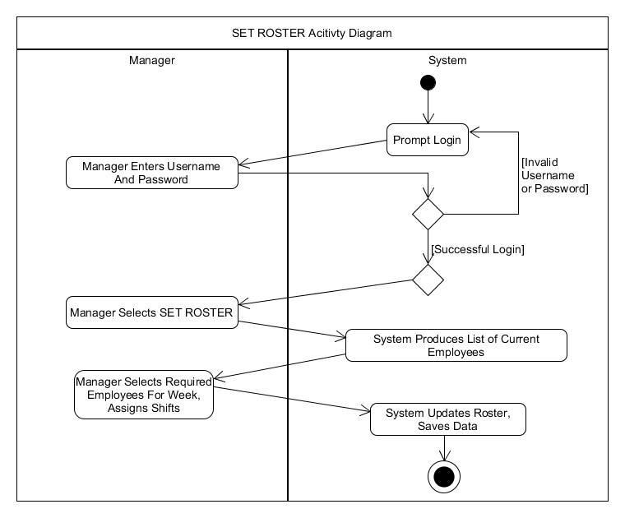

# 

# Part 4:

*Class Diagram*

# 